|  |  |
| --- | --- |
| Course name | Numerical Modeling & Simulation in Scilab Xcos |
| **Lesson name** | **Numerical Modelling Formula 1 Vehicle Resistive Forces in Scilab-Xcos** |
| **Lesson objective** | **Practice blocks &** **acquaint to use GUI of Scilab-Xcos** |
| Created by | Bharath Kumar P |

**Problem statement:** Model the Formula 1 Vehicle Resistive Force in Scilab-Xcos to plot the vehicle resistive force.

**Track Drive Cycle Graph:**

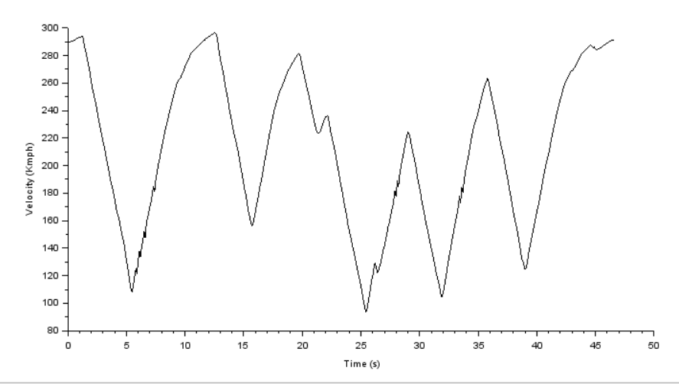

**Model Inputs:**

|  |  |  |  |
| --- | --- | --- | --- |
| **Sl No** | **Parameter** | **Value** | **Units** |
|  | **Chassis** |  |  |
|  | 1. Coefficient of rolling resistance | 0.015 |  |
|  | 1. Gross Vehicle Mass | 900 | Kg |
|  | 1. Gravity constant | 9.81 | m/s |
|  | 1. Grade Angle | 0 | degree |
|  | 1. Area | 1.8585 | m^2 |
|  | 1. Air Density | 1.225 | Kg/m^3 |
|  | 1. Drag Coefficient | 0.9 |  |
|  | 1. Radius of wheel | 0.2286 | m |

**Program:**

|  |  |
| --- | --- |
| 1. **To Import Track Data:** | 1. **To define all input parameters:** |
| *//Importing Drive Cycle Data*  data = csvRead("C:\Users\user\Documents\SciLab\Week 2\track.csv")  Drive.time = data(3:470,1);  Drive.values = data(3:470,2); | //Coefficient of Rolling Friction  Crf = 0.015  //Gravitational Constant  g = 9.81  //Gross Vehicle Weight  GVM = 900 //kgs  GVW = GVM*g  //Frontal Area  A = 1.8585  //Air density  rho =1.225  //Coefficient of Drag  Cd = 0.9  //Radius of Wheel  Rw = 0.2286 |

**Results:**

|  |
| --- |
| **Vehicle Resistive Forces** |
|  |

|  |
| --- |
| **Wheel** |
|  |

**Conclusion:**

|  |  |  |  |
| --- | --- | --- | --- |
| **Sl No** | **Parameters** | **Values** | **Units** |
|  | **Chassis** |  |  |
|  | * Rolling Force | 132.42 | N |
|  | * Gradeability Force | 0 | N |
|  | * Maximum Aerodynamic Force | 6264 | N |
|  | * Maximum Acceleration Force | 28225 | N |
|  | * Maximum Wheel Speed | 3351 | Rpm |
|  | * Maximum Wheel Torque | 6337 | Nm |